Income Tax System
Issues:

1. Report Format need to be set for all the stages.
2. Tracking of all work and it should give on which stage it is present
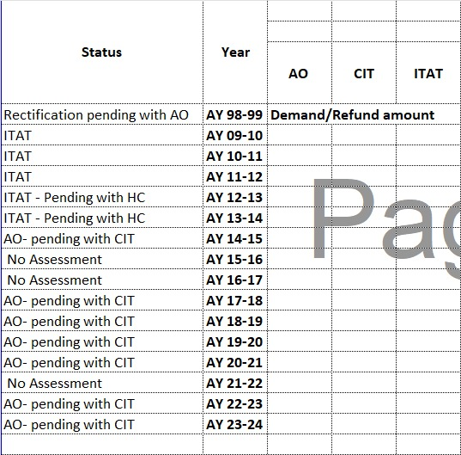
3. This is another format for final year-wise summary chart
in blank columns there will be amounts

Income Tax Return ( ITR ) Model :

Formulas:

- Year : AY yyyy-yyyy

- Gross Total Income: (disallowance_37 + gross_total_income)
- Disallowance 14A:
- Disallowance 37: (disallowance_14a + disallowance_37)

- Deduction 80Ia Business:
- deduction_80ia_misc :
- deduction_80ia_other :
- deduction_sec37_disallowance : (deduction_80ia_business + deduction_80ia_misc + deduction_80ia_other - 1.35)
- deduction_80g :

- net_taxable_income :(gross_total_income - deduction_sec37_disallowance - deduction_80g)

- tax_30_percent : (net_taxable_income * 30%)
- tax_book_profit_18_5 :

- tax_payable :(tax_book_profit_18_5)

- surcharge_12 :(tax_payable * 12%)
- edu_cess_3 : ((tax_payable + surcharge_12) * 3%)

- total_tax_payable :(tax_payable +surcharge_12+edu_cess_3 )
- mat_credit :

- interest_234c :
- total_tax : (total_tax_payable + mat_credit + interest_234c)

- advance_tax :
- tds :
- tcs :
- tax_on_assessment : (advance_tax + tds + tcs )

- refund : (total_tax - tax_on_assessment)

Income Tax Return ( ITR ) Model :

Formulas:

- Year:
- gross_total_income:
- disallowance_14a :
- disallowance_37 :

- deduction_80ia_business :
- deduction_80ia_misc :
- deduction_80ia_other :
- deduction_sec37_disallowance : (deduction_80ia_business + deduction_80ia_misc + deduction_80ia_other - 1.35)
- deduction_80g :

- net_taxable_income :(gross_total_income - deduction_sec37_disallowance - deduction_80g)

- tax_30_percent : (net_taxable_income * 30%)
- tax_book_profit_18_5 :

- tax_payable :(tax_book_profit_18_5)

- surcharge_12 :(tax_payable * 12%)
- edu_cess_3 : ((tax_payable + surcharge_12) * 3%)

- total_tax_payable :(tax_payable +surcharge_12+edu_cess_3 )
- mat_credit :

- interest_234c :
- total_tax : (total_tax_payable + mat_credit + interest_234c)

- advance_tax :
- tds :
- tcs :
- tax_on_assessment : (advance_tax + tds + tcs )

- refund : (total_tax - tax_on_assessment)

AO Form model :

- Year:
- gross_total_income:
- disallowance_14a :
- disallowance_37 :

- deduction_80ia_business :
- deduction_sec37_disallowance :
- deduction_80g :
- net_taxable_income :(gross_total_income + disallowance_14a + disallowance_37)- (deduction_80ia_business + deduction_sec37_disallowance) - deduction_80g

- tax_30_percent : (net_taxable_income * 30%)
- tax_book_profit_18_5 :

- tax_payable :(tax_book_profit_18_5)

- surcharge_12 :(tax_30_percent * 12%)
- edu_cess_3 : ((tax_30_percent + surcharge_12) * 3%)

- total_tax_payable :(tax_30_percen +surcharge_12+edu_cess_3 )

- mat_credit : (((tax_30_percent + tax_book_profit_18_5) * 12%) * 3)

- interest_234c :
- total_tax :(total_tax_payable + mat_credit + interest_234c)

- advance_tax :
- tds :
- tcs :
- tax_on_assessment :(advance_tax + tds + tcs )

- refund :(total_tax - tax_on_assessment)

CIT model

- Year:
- gross_total_income:
- disallowance_14a :
- disallowance_37 :

- deduction_80ia_business :
- deduction_sec37_disallowance :

- deduction_80g :

- net_taxable_income :(gross_total_income + disallowance_14a + disallowance_37)- (deduction_80ia_business + deduction_sec37_disallowance) - deduction_80g

- tax_30_percent : (net_taxable_income * 30%)
- tax_book_profit_18_5 :

- tax_payable :(tax_book_profit_18_5)

- surcharge_12 :(tax_book_profit_18_5 * 12%)
- edu_cess_3 : ((tax_book_profit_18_5 + surcharge_12) * 3%)

- total_tax_payable :(tax_payable + surcharge_12 + edu_cess_3 )
- mat_credit :

- interest_234c :
- total_tax :(total_tax_payable + mat_credit + interest_234c)

- advance_tax :
- tds :
- tcs :
- tax_on_assessment :(advance_tax + tds + tcs )

- refund :(total_tax - tax_on_assessment)

Income Tax software – Pending point.
- Login page. -- Swapnil
- Sidebar add on software and show click to show. -- swapnil
- Report Format need to be set for all the stages. Tracking of all work and it should give on which stage it is present

25-12-2025
Client changes and adding.
Sr.No | Required Changes on from and Review | Status
1 | Set formulas of ITR , AO and CIT from | Done
2 | add in percentage enter and calculate Amount with not editable field with different colure. | Done
3 | Required changes of Auto calculation in from and UI design. | Done
4
5

26-12-2025

Sr.No | Required Changes on from and Review | Status
1 | Add remark field in all from also add database column and save storproc. | done
2
3 | Testing ITR from entry and AO from.
4

27-12-2025 – Pending List

Sr.No | Required Changes on from and Review | Status
1 | AO from not working properly set formulas | Done
2 | Need to field name change Mat Credit(MAT Credit created) to Less : MAT Credit utilized
3 | UI changes need o be fields are one line two fields show
4 | Add new field in all from name as SAT – TCS field after position | New
5 | Apply Surcharge(Percentage of calculation) also need to be add Tax @ 30% (A) and Tax @ 18.5% on Book Profit (B) | New
6 | ITAT from need to same like ITR from (all from need to be same ) | New
7 | New concept of Mat credit use how to use and how to calculate previse uses pending and use. | New
8 | UI properly show Laptop, Desktop and Mobile view.
9 | Report of model and year selected generate  - Title of report year mentions like ex. AY 2025 - 2025  - Heading are properly as per sheet .  - All model data show with selected year.  - And particular columns are bolds (total calculate, refund columns) .  - All report download.
10 | Summary report up to this year’s generate and Download.
11

